Care and Support Program – Backpack and Supplies Distribution
On June 21, 2009, 30 children of HIV positive mothers were given backpacks and school supplies provided by the Center for the Church and Global AIDS. There was a gathering of the women and the children at the TCDS offices in Vandalur outside of Chennia, Tamil Nadu. 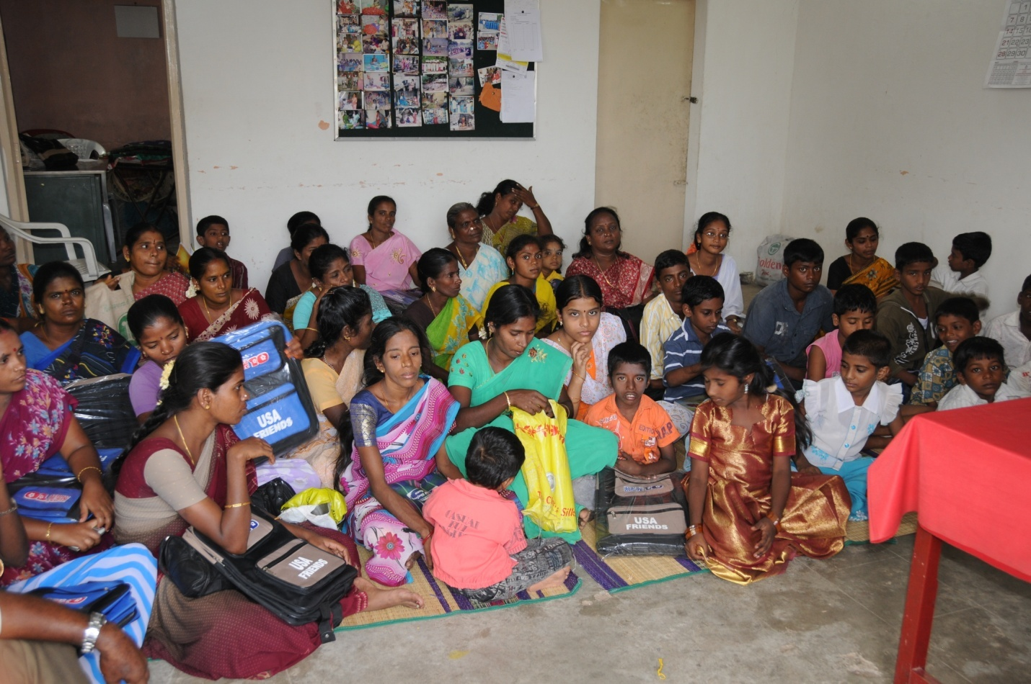
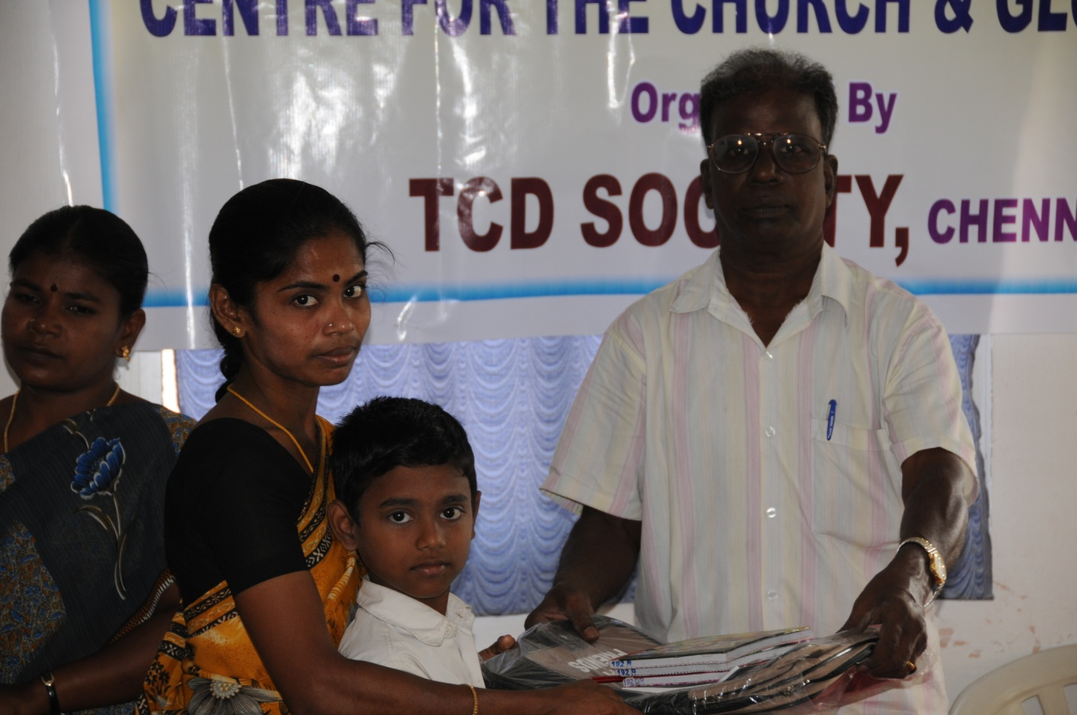
Pastor Dhanaraj handing out backpack and supplies
The children’s school year begins in June. They are thrilled with their new supplies. I was lucky enough to be in India in June, so I got the pleasure of passing out the backpacks (even though I don’t have a picture of it). Thanks CCGA!
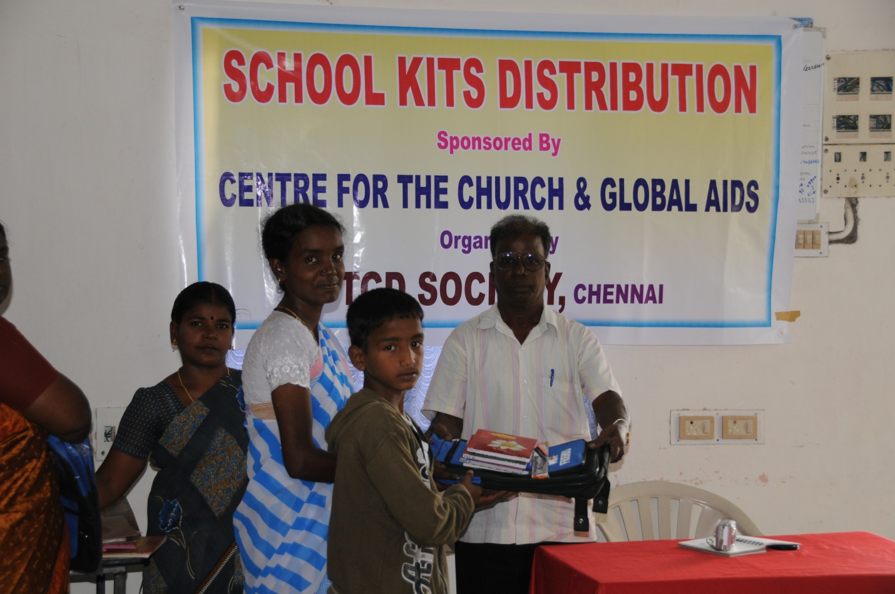
Some of the mothers and children sang to entertain the group until lunch was ready.
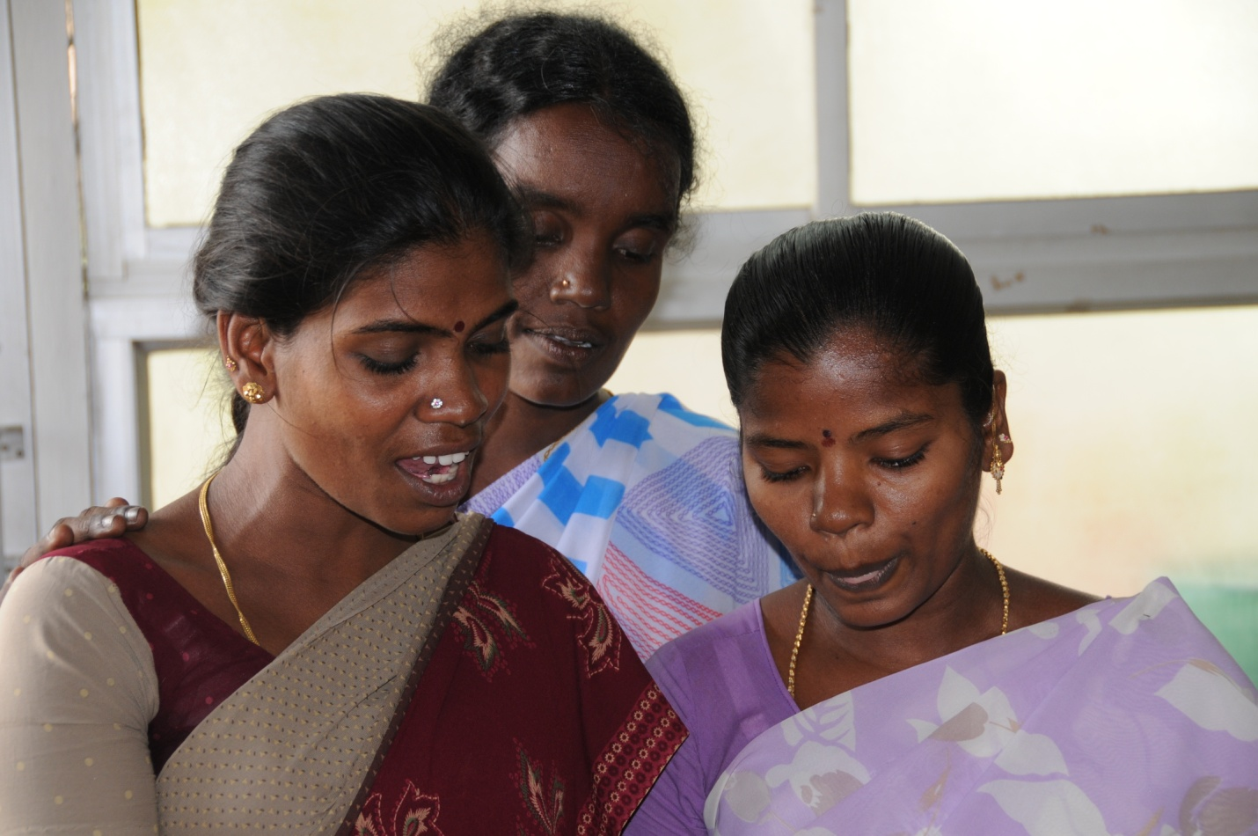
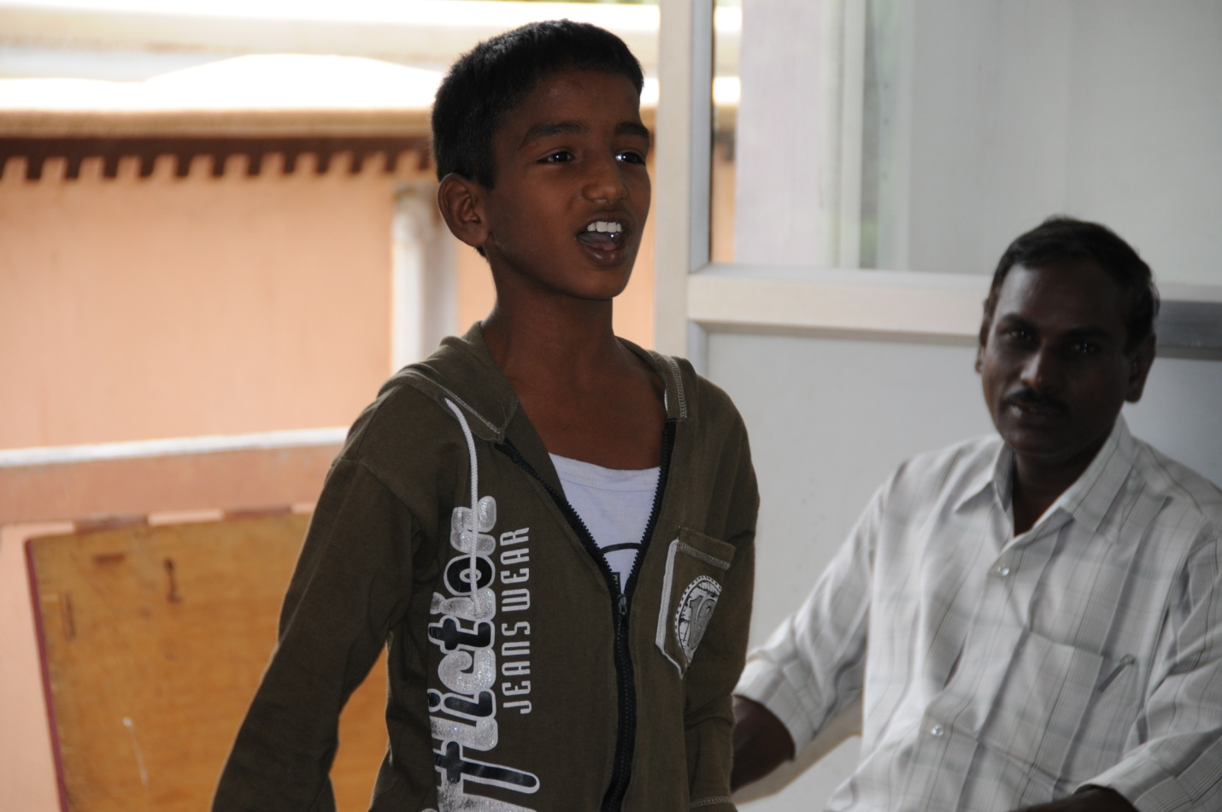

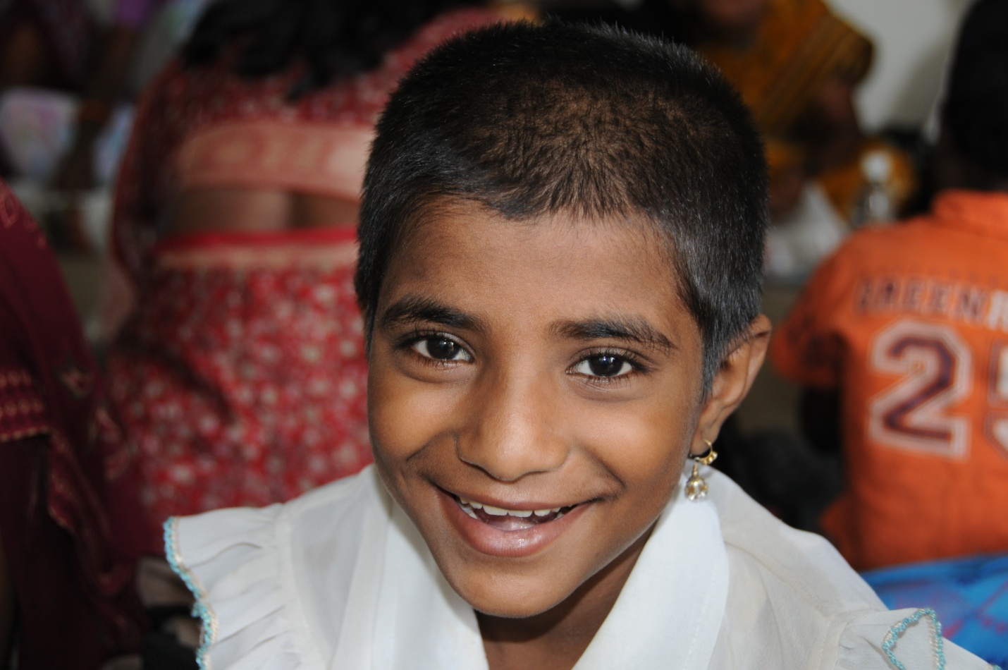
I got to see this smile in person!
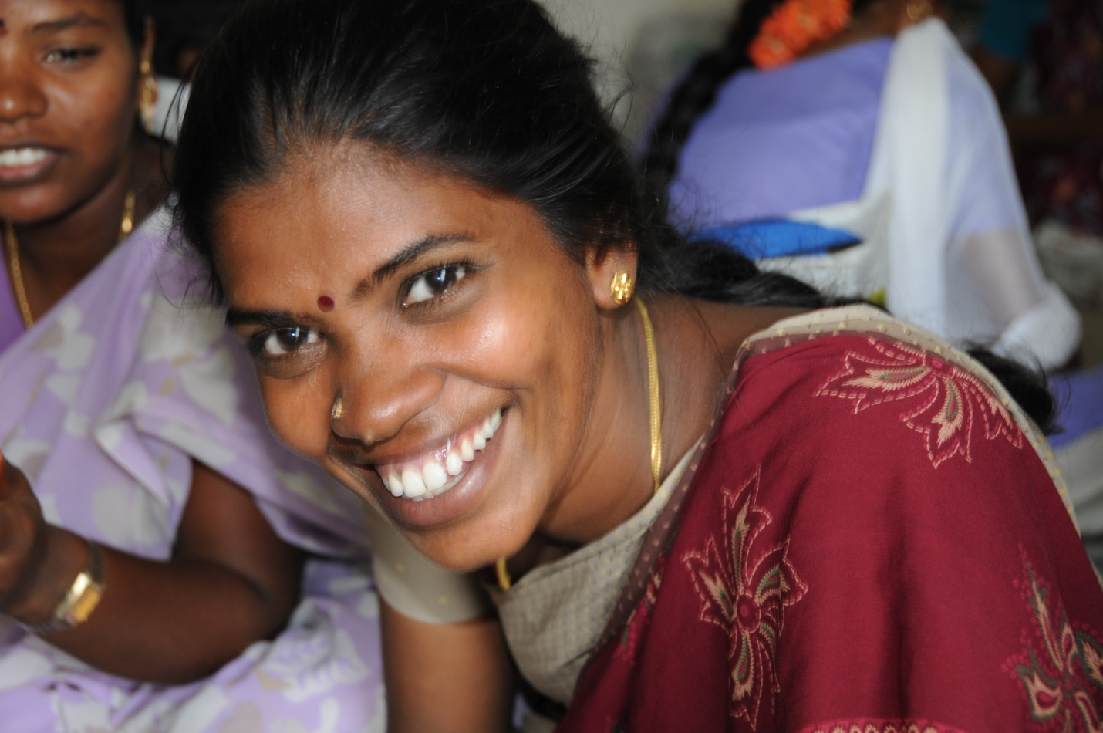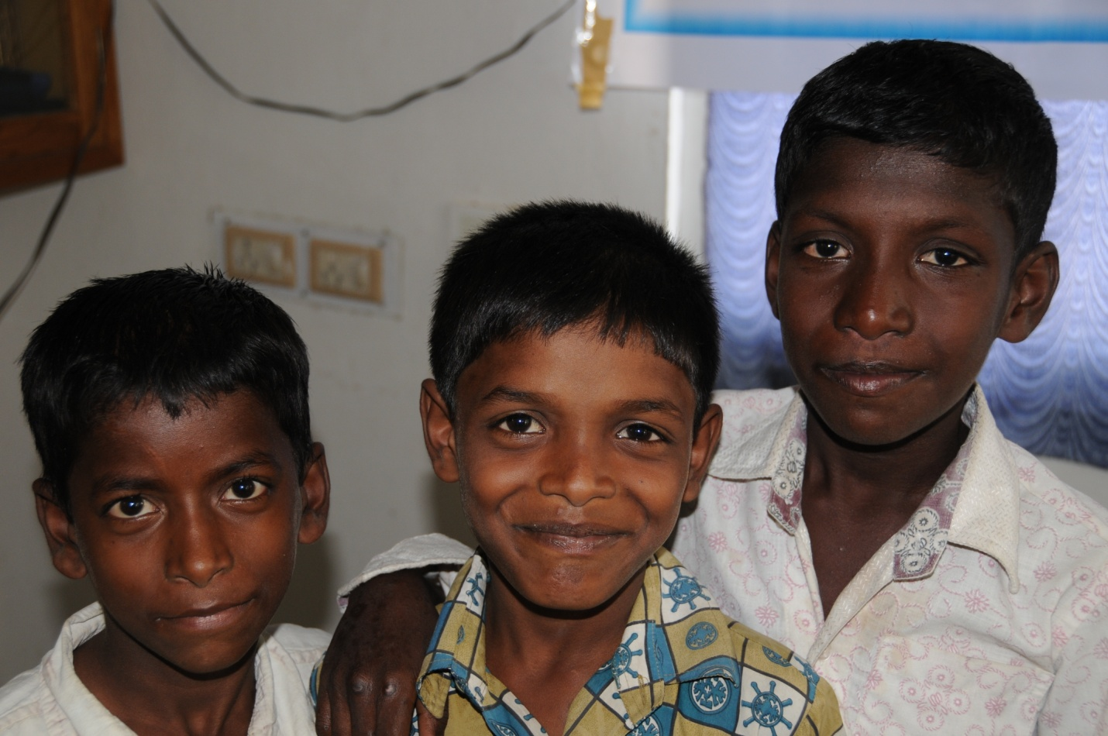
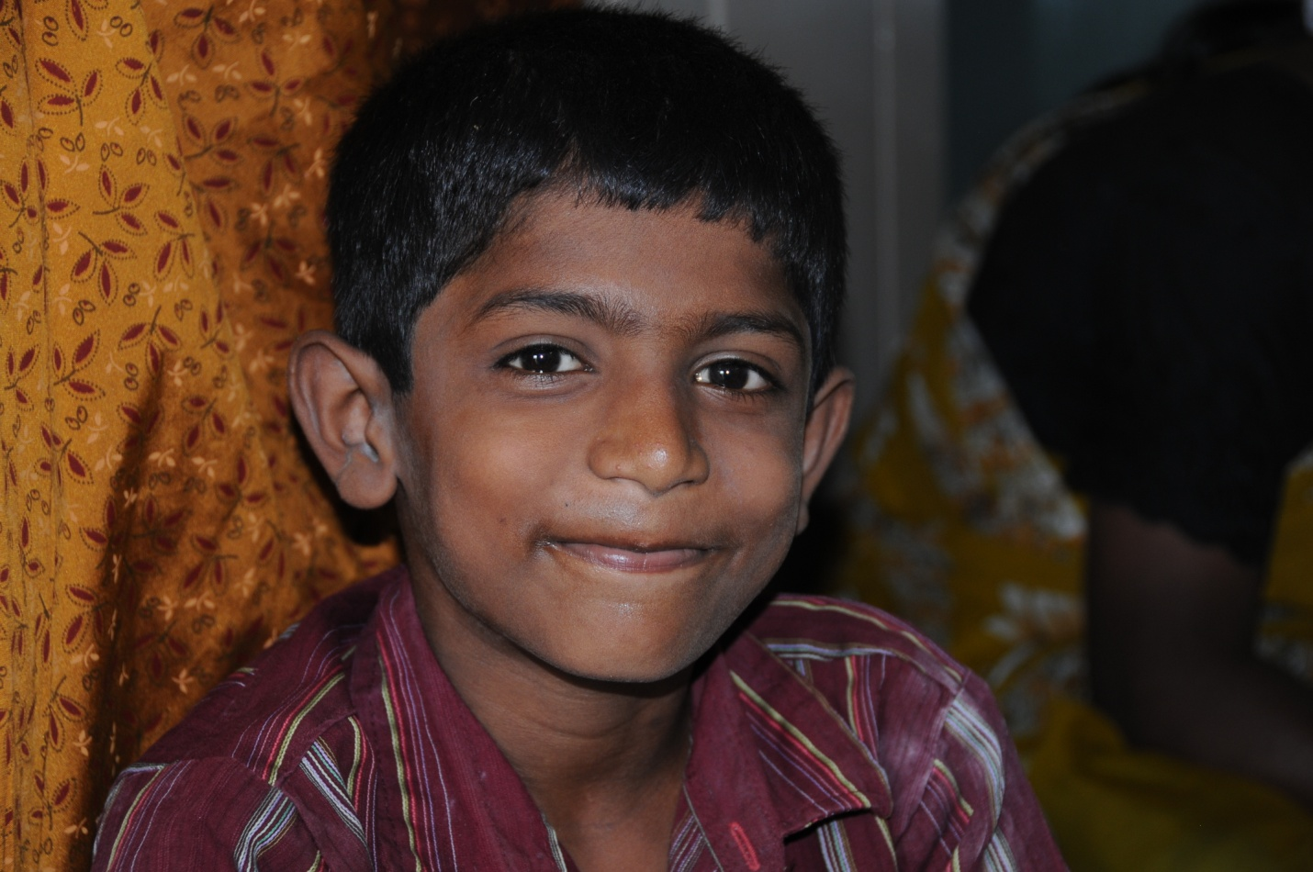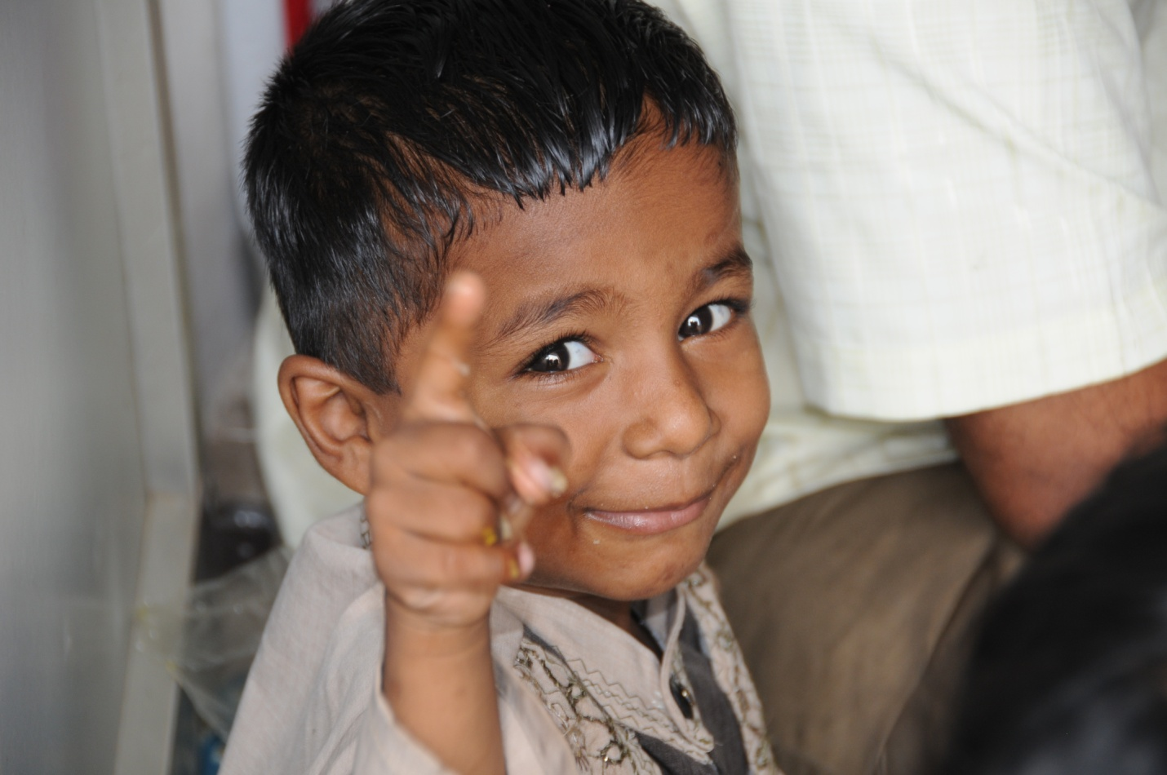
Thank the Lord for cameras!
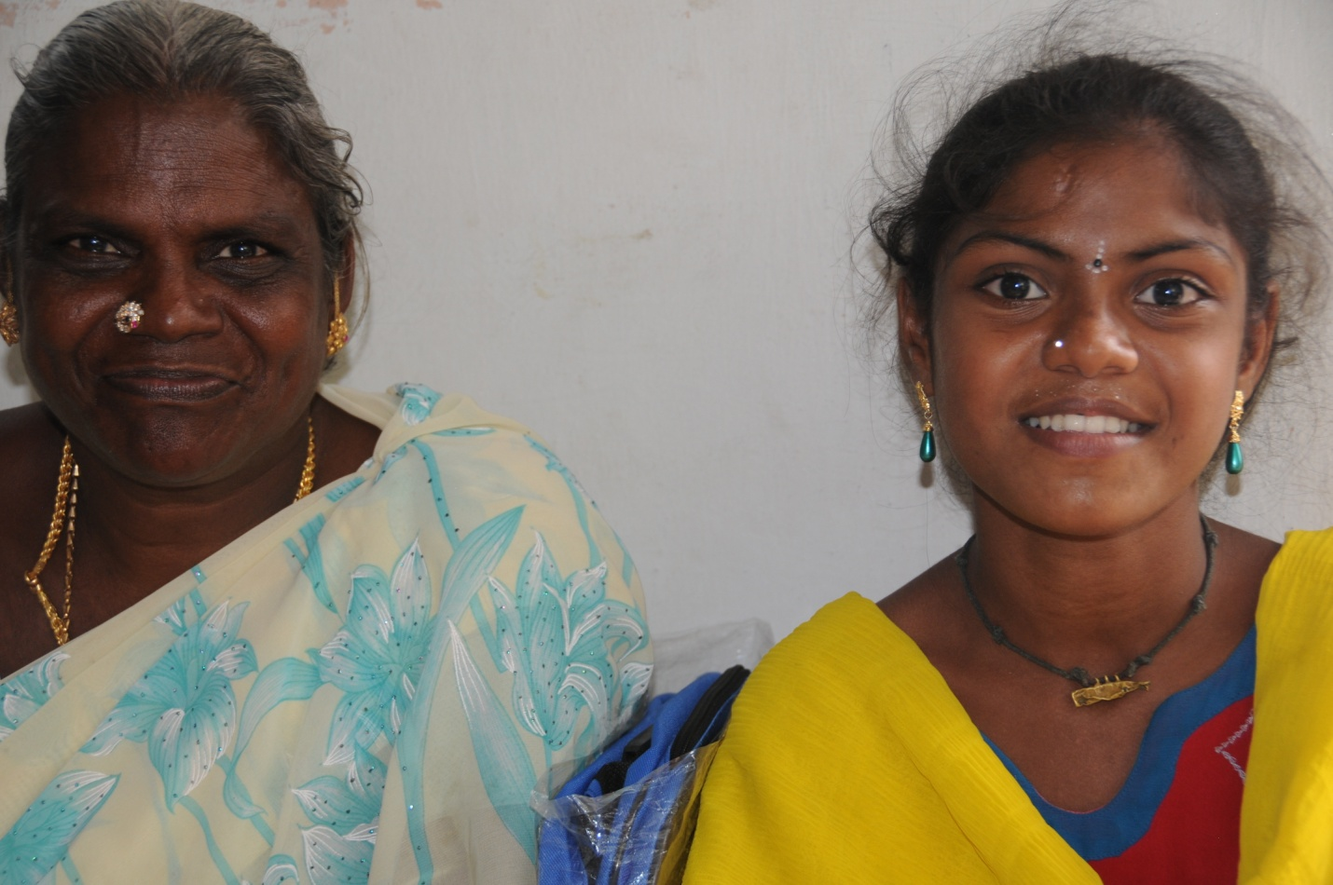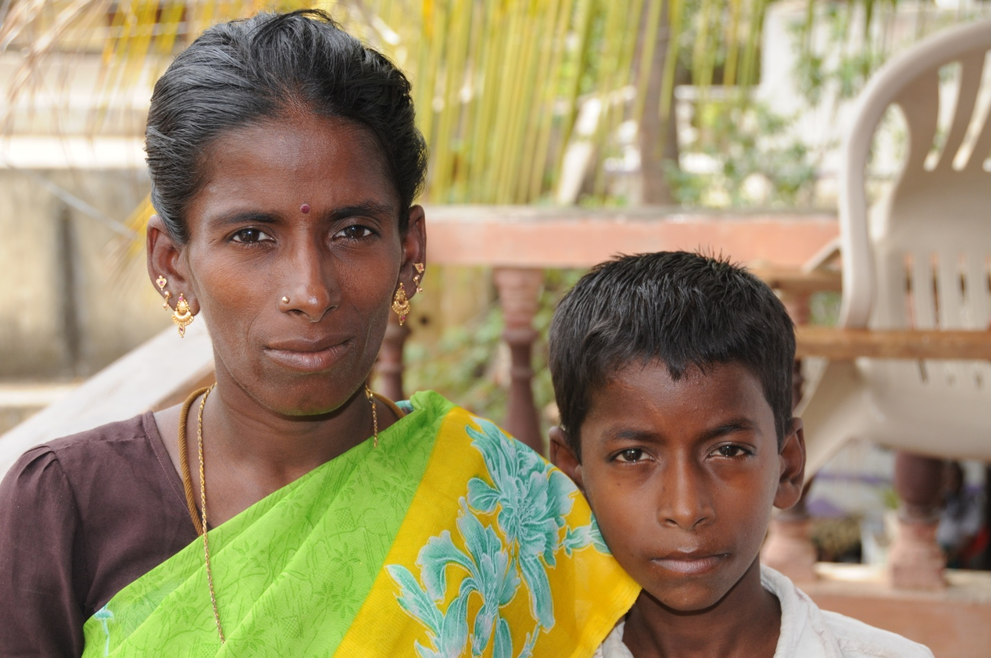

Vijay measured and weighed the children.